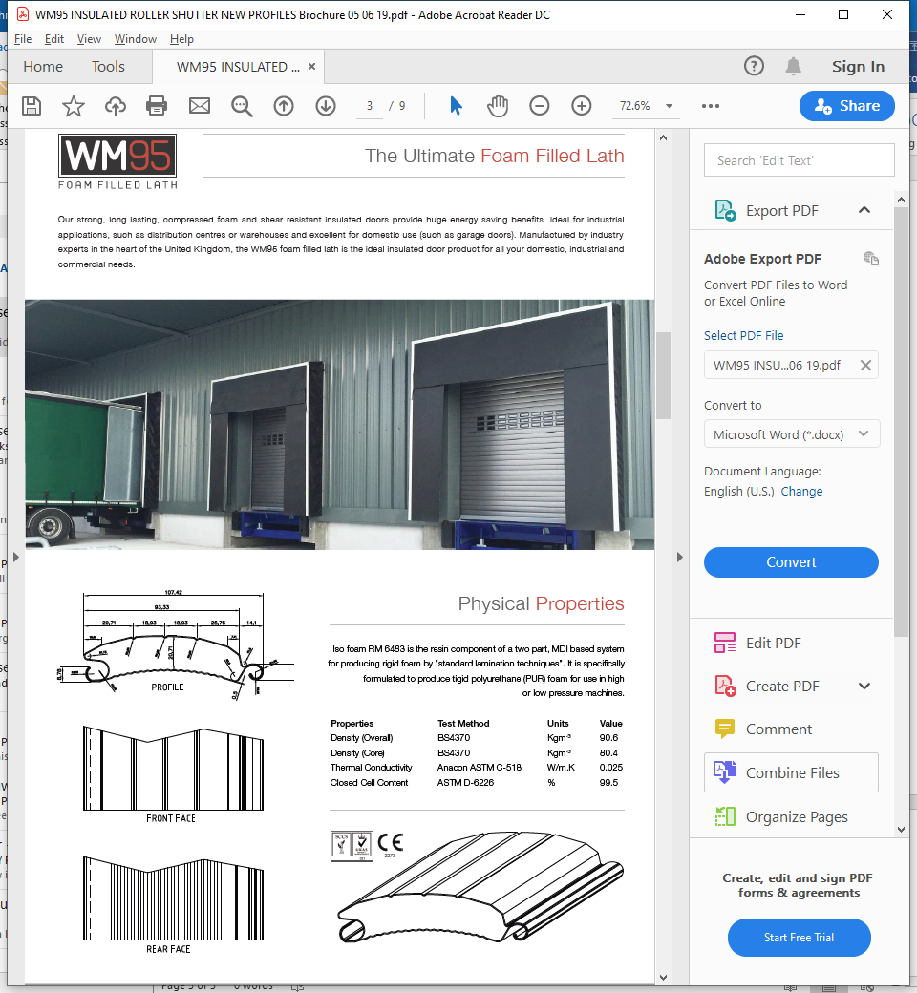

Bolton: 01204 918991  
Bradford: 01274 79 2889  
Blackpool: 01253 67 5889  
Leeds: 0113 328 0245  
Liverpool: 0151 324 0250  
Manchester: 0161 298 4025

[sales@ukdoorsandshutters.co.uk](mailto:sales@ukdoorsandshutters.co.uk)

